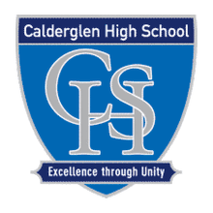

SQA Mental Health and Wellbeing Award
Calderglen High School
"How Calderglen Sees It"- Our journey as a class through the SQA Mental Health Award.
At Calderglen High School we introduced the Level 5 SQA Mental Health Award for the first time during the 2019-2020 session. We made this a curriculum option for our young people in S5 and S6.
We had a small class of 13 pupils who were all very passionate about mental health and wellbeing. They used the class as an opportunity to learn more about mental health and use their platform to reduce the stigma around talking about it or asking for help.
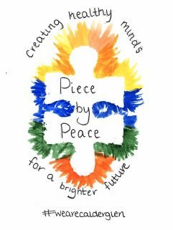
One of the first things we did was create a logo - we wanted to use this in our promotion of any events or resources we created for YP, their families and staff.

In August we decided to create a strategic plan for the year. What did we want to achieve for Calderglen? Every one of our young people were committed to leading change for pupils, their families, and staff across the Learning Community. This was our plan which we presented to our Senior Management Team. They were very supportive of the HWB group and encouraged the work they wanted to do!
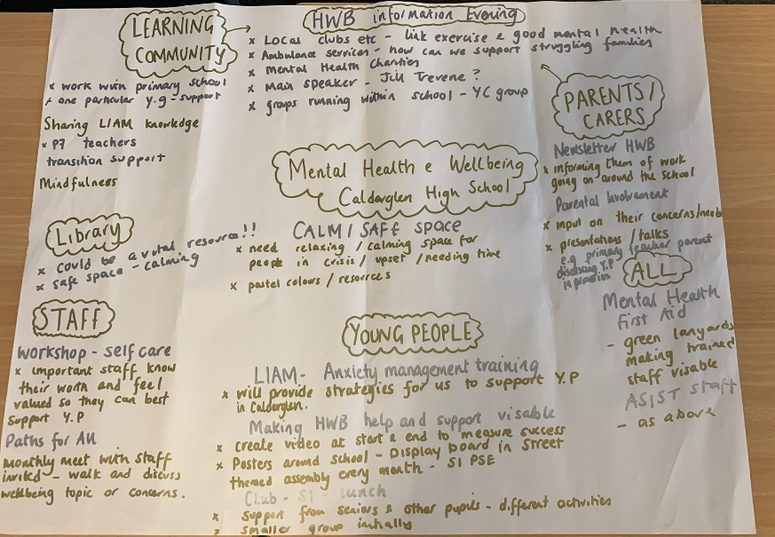

The class then received anxiety management training from Suzanne Mills and her colleagues from CAMHs. They learned what anxiety is, coping strategies, and how to talk to a child or young person who is experiencing it. This was such a worthwhile experience for the class and was key to our work around transitions.
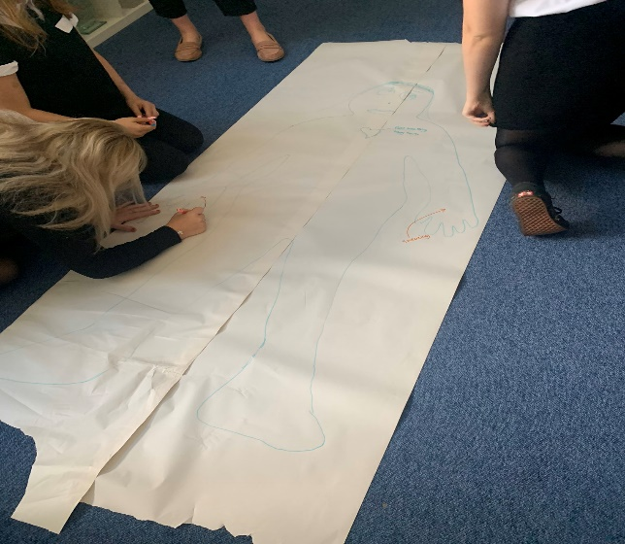
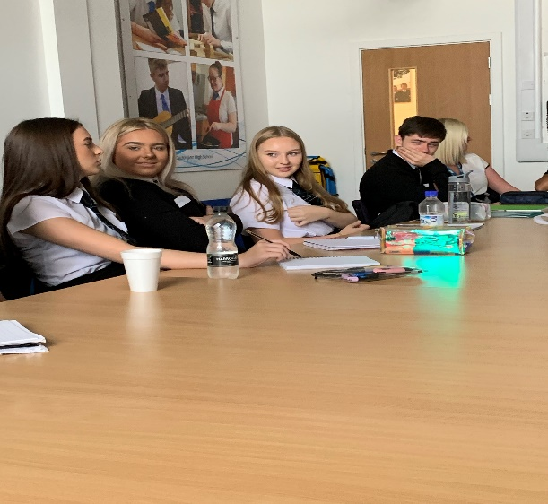

The pupils then created a Staff Mental Health Protocol. This was to support staff when they were helping a young person with their mental health. We worked with our Art Department and DHTs to create this – we are hoping to distribute to staff next session.
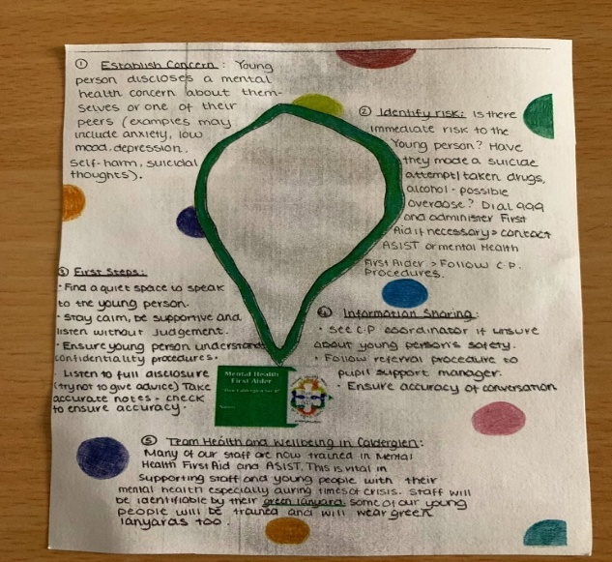
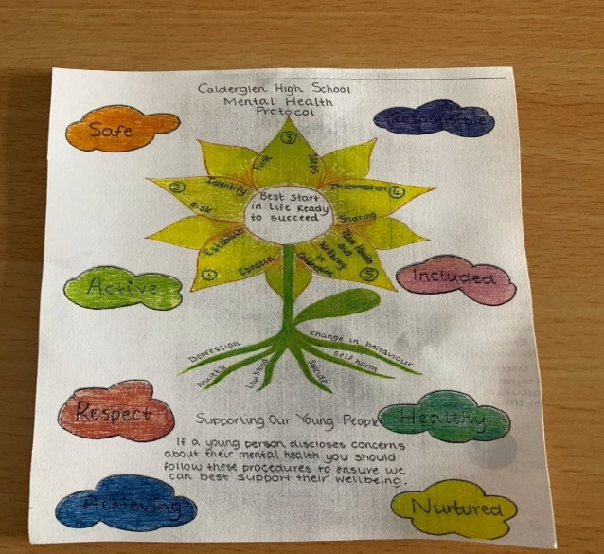

To start the work we wanted to do around P7 Transitions we hosted a Primary Pupil Voice event at the school – we invited 2 representatives from each of our learning community schools and the HWB group explored what support they needed from school and those who look after them to feel safe, be happy and achieve their potential. Lots of fun activities and amazing discussions!
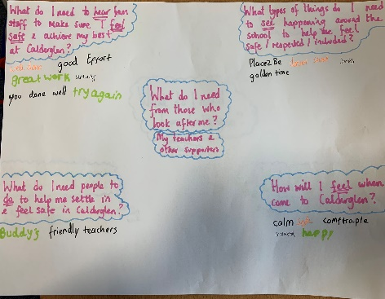
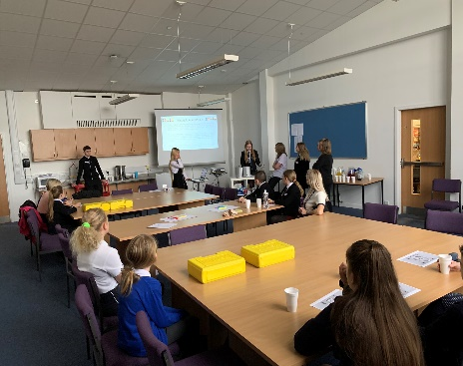
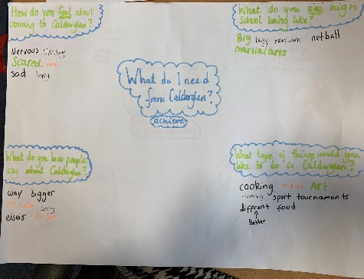

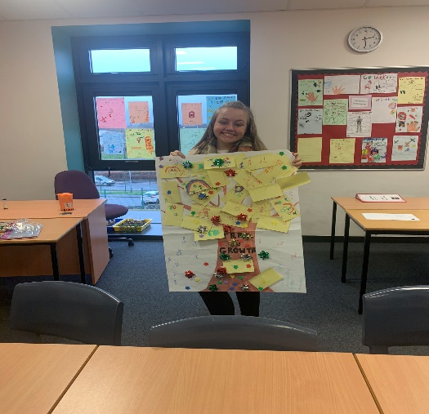
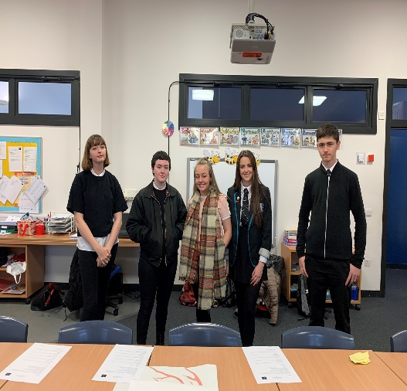

As part of our strategic approach for the year we were supported by the Elizabeth B Mitchell fund to organise a Learning Community Health and Wellbeing event. The rationale of the event was to support families in the community with their mental health and have a more consistent approach to health and wellbeing across the learning community.
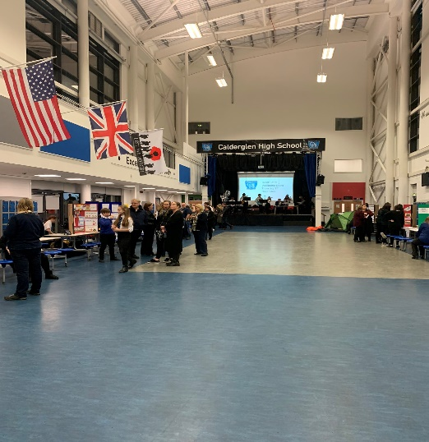
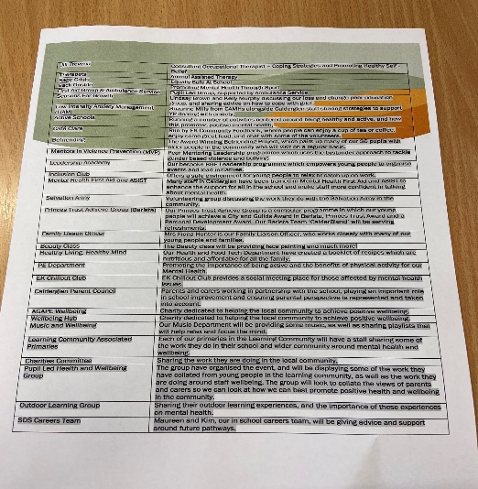

We called it ‘How Calderglen Sees it – A Learning Community Approach to Health and Wellbeing.’ The planning and organisation that went into this event by the class was incredible. They sourced and contacted local community groups and partners, encouraged staff to get involved and arranged a key speaker for the night – Occupational Therapist Jill Trevena.
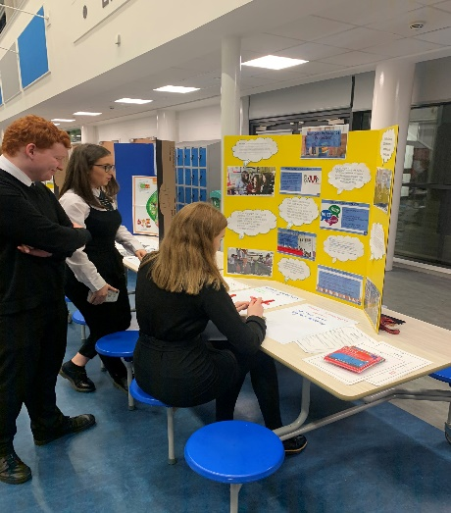
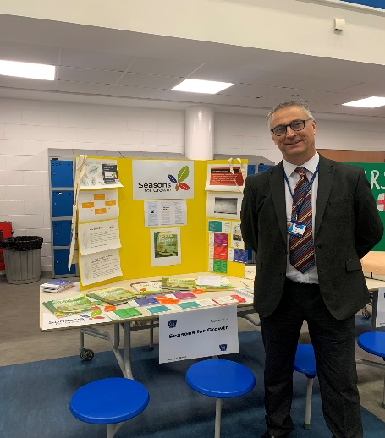
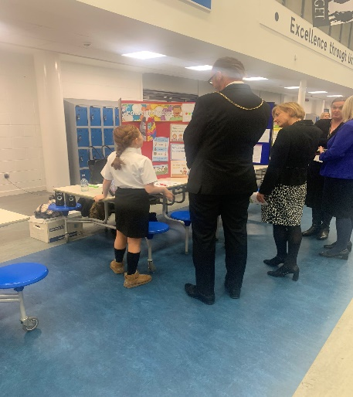

Every school in the Learning Community was represented and it was such an amazing opportunity to network with each other. We worked with staff and young people to include many of the groups in the school that help support and promote health and wellbeing – the response was amazing and everyone really went out their way to create a stall that would be informative for our parents and carers. This event was a real example of young people leading change and it allowed us to develop partnerships in the local community - we are now committed to making this an annual event!

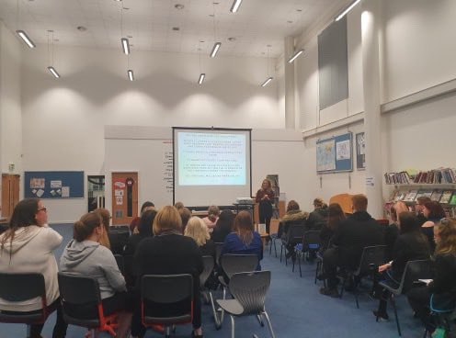
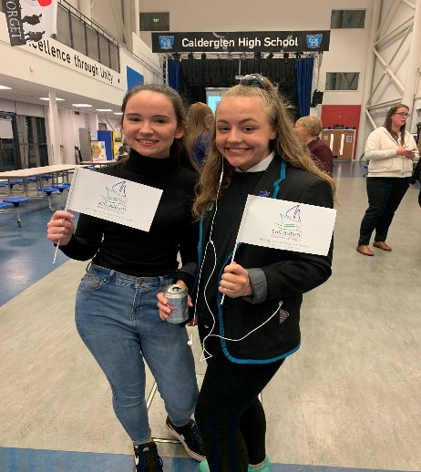
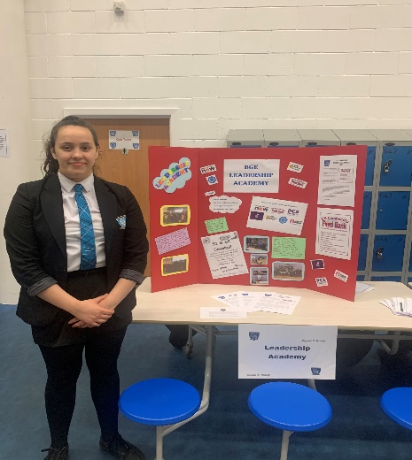

Staff wellbeing was a priority for the class. They felt that for staff to be able to emotionally support young people we need to make sure there are opportunities for them to reflect on their own wellbeing, as well as training to gain the skills and confidence to cope with helping others with any issues or concerns young people may have. We spoke with staff across the school to collate their views and created a mind map detailing what they needed. The class presented this to senior management who agreed to support some of the ideas that we had come up with. We created a staff CLPL and wellbeing bulletin that will be sent out every term. It will have a different focus each time and will help meet the needs of staff with professional learning opportunities, as well as chances to socialise with their colleagues and get involved in physical activities.
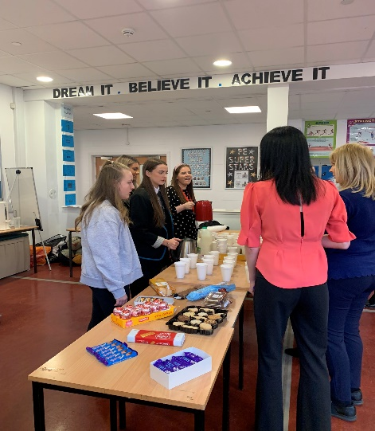
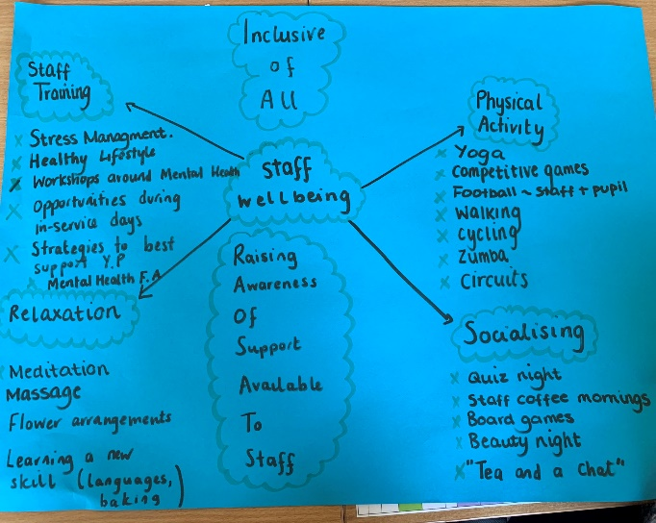
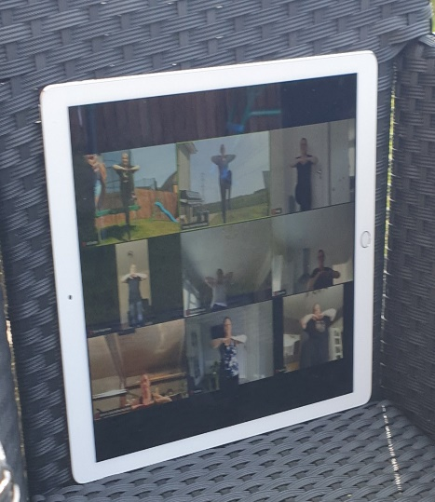

How did the course benefit young people and staff?

Kelly Murphy – Teacher of Health and Wellbeing

“I really enjoyed teaching the Mental Health and Wellbeing course. It has been amazing to have the opportunity to teach young people about mental health and also have more in-depth discussions around their thoughts and feelings about wellbeing. It has been such a valuable experience for me as a Pupil Support Manager as I have been able to use the knowledge I have gained in PSHE delivery, and the feedback and insight of the class has really helped with this. Health and Wellbeing is a huge priority in Calderglen and having this class involved in the planning and delivery of wellbeing events, as well as being a part of strategic and improvement planning for the whole school has been so important. Working together to lead change - young people, staff, parents and partners - has made our commitment to reduce sigma around mental health even stronger and I am so proud of the impact this class has had. This is down to the incredible young people that were involved and the support of senior management.’’

Emma Spence – S6 Pupil

“Having the opportunity to be part of the Level 5 Mental Health and Wellbeing class was the highlight of my final year at school. Not only did I learn more about the different forms of mental health that can impact on so many people in their daily life, I also learned so much more about myself. This course allowed me to experience speaking to large groups of people such as our local primary schools, and it also made me more recognisable within the school community as I represented the school at a variety of events. Not only did it improve my confidence, it also persuaded me to change my career path and further my knowledge by going on to study psychology. I hope that in my future I will be able to continue doing work just like I did during my year of mental health and wellbeing .
The mental health and wellbeing class aimed to improve the mental health of the pupils, however we also wanted to improve the mental health of the staff within our learning community. After lots of discussion we came to the conclusion that we can’t expect our teachers to teach our pupils about having positive mental attitudes if they weren’t feeling it themselves. To help with this we set up weekly activities for our staff to participate in such as Zumba, mindfulness, baking and even just a catch up and coffee at the weekly quiz. This continued during lockdown. The staff loved this idea as it allowed them to have time to switch off and enjoy their time with their colleagues.”
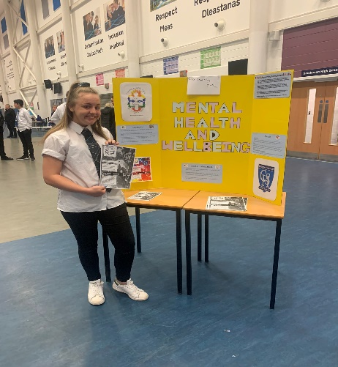
Abigail Gibson – S5 Pupil

“I enjoyed this class so much – not only did I make forever friends, but I was able to make a difference on the outlook of young peoples mental health. Such an amazing and enlightening subject that I loved every single period of.”

